SKR & SKR Govt. College for Women (A), Kadapa
Alumni association
ACTIVITY REGISTER
S.No. | Activity Conducted | Academic Year | Date and Time
1 | Best Practice  CLEAN AND GREEN | 2021-2022 | 23-03-2022
2 | Best Practice Hand Full of Rice | 2021-2022 | 09-05-2022
3 | Presenting Saree to Ammavaru | 2021-2022 | 18-08-2022

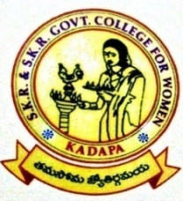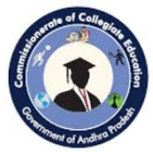
ALUMNI ASSOSIATION
EVENT REPORT
SKR & SKR Government College for Women (A)
Kadapa

----------------------------------------------------------------------------------------------------------------
ACTIVITY: Best Practice | A.Y: 2021-2022 | DATE: 23-03-2022

“CLEAN AND GREEN”
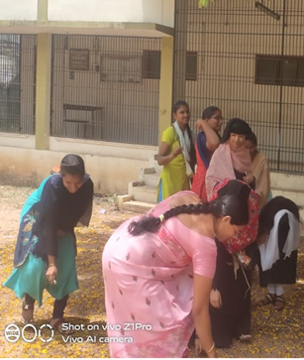
TOPIC: Clean and Green
Synopsis of the Topic:
Clean and green environment imply
absence of pollution and a better quality of life.
Green on the other hand has a direct link to
promoting good health. Literally a green
environment means abundance of trees and
greenery. Trees are instrumental in purifying air
by absorbing the dangerous gases and giving out
Oxygen.
The Clean and Green campaign aims to
protect and care for the environment by engaging
the community in leading an environmentally
conscious lifestyle. It is currently administered
by the National Environment Agency.
Establishment.
50 Ways to Go Green
Start a family “go-green fund.” Review your
previous water, gas and electric bills. ...
Create your own wrapping paper or gift bags
out of magazines, scrap cloth or newspaper.
Make it a contest. ...
Plant trees together.
Adopt a road or park, and pick up litter.
Build a compost bin together. ...
Plant a garden.

Feedback: Excellent

Faculty involved: Alumni Faculty
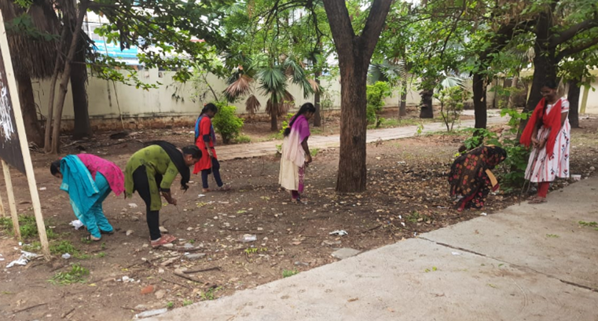
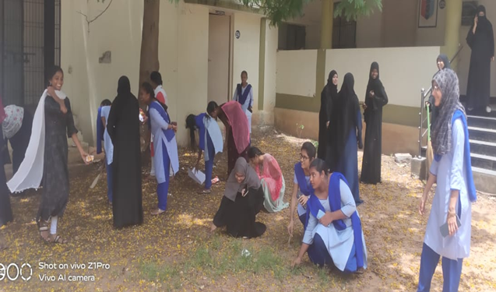
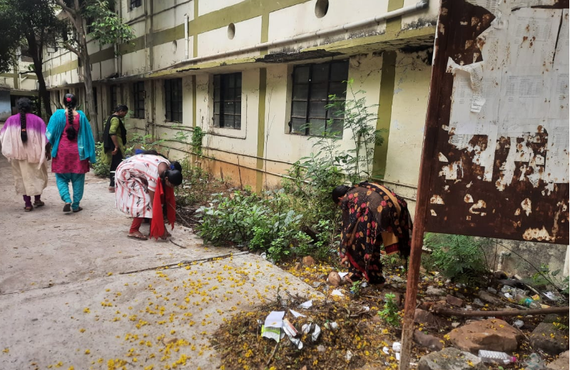

ALUMNI ASSOSIATION
EVENT REPORT
SKR & SKR Government College for Women (A)
Kadapa

----------------------------------------------------------------------------------------------------------------
ACTIVITY: Best Practice | A.Y: 2021-2022 | DATE: 09-05-2022

“Hand Full of Rice”
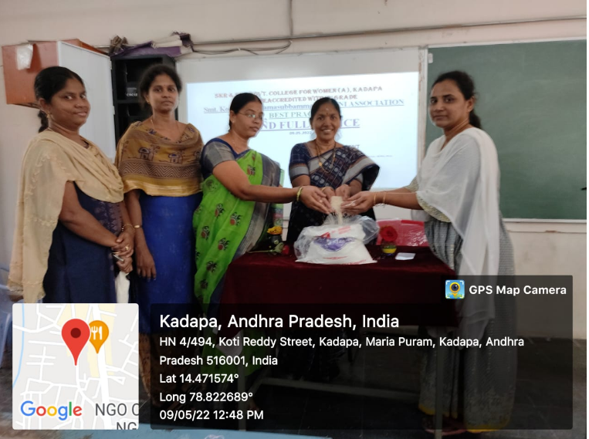
TOPIC: Hand Full of Rice
Synopsis of the Topic:
Buhfai tham ('handful of rice') was
started inthe state of Mizoram in north-east
India in 1910. It is a practice where each
family, mainly from the Mizo ethnic group,
puts aside a handful of rice every time they
cook a meal. Later, they gather it and offer it
to the church.

Rice: A fist-sized portion of cooked rice equals
100 g, has around 130 cal, and is a great source
of carbohydrates. Vegetables: 2 handfuls of
mixed vegetables equals 150 g and has
approximately 82 cal. Fruit: A handful of mixed
fruit equals 80 g and has about 42 cal.

Feedback: Excellent

Faculty involved: Alumni Faculty
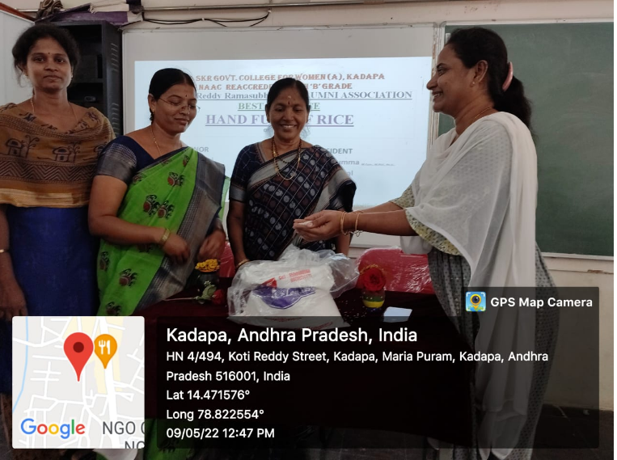
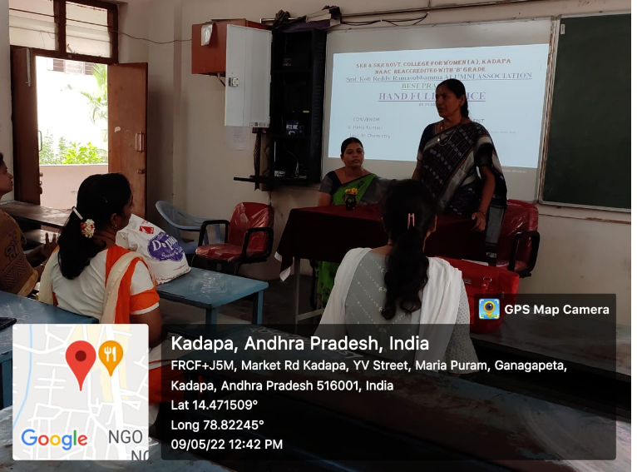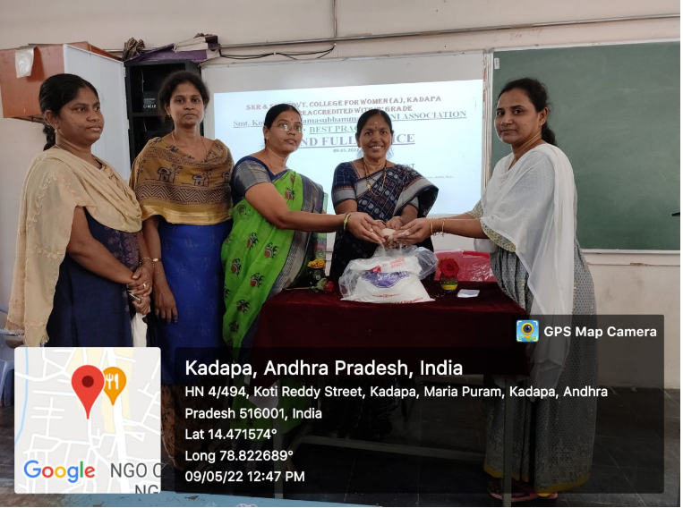
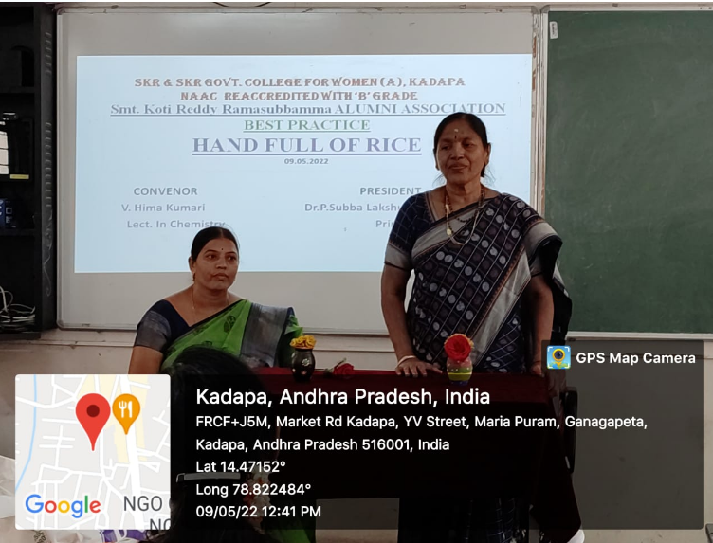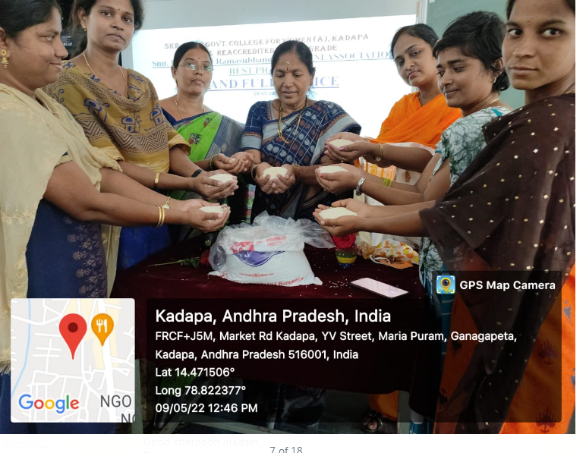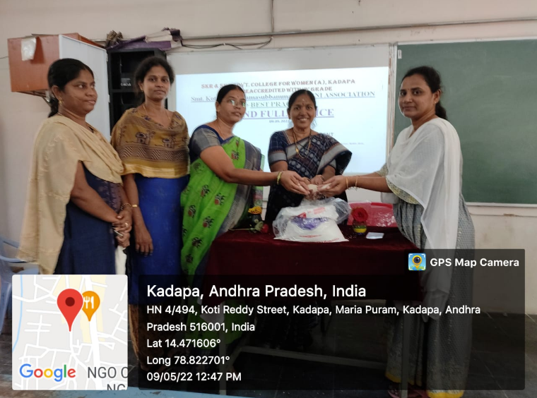

ALUMNI ASSOCIATION
EVENT REPORT
SKR & SKR Government College for Women (A)
Kadapa

----------------------------------------------------------------------------------------------------------------
ACTIVITY: Presenting Saree to Ammavaru by Alumni Association | A.Y: 2021-2022 | DATE: 18-08-2022

“Presenting Saree to Ammavaru by Alumni Association”
TOPIC: Presenting Saree to Ammavaru by
Alumni
Synopsis of the Topic:
Alumni Meet is a gathering of passed out
students of an institution and it is a place where
the institution feels proud on seeing its successful
alumni. During their meet, the alumni community
shares their experience in the outside world, Which
they faced after stepping out of the institution.
Alumni associations offer a number of ways
to give back, including gifts, endowments,
membership fees, and volunteer opportunities.
Giving back to an alumni association is a great
way to keep the legacy going and ensure that
future generations of students have the opportunity
to pursue quality higher education.
Maa (Mother) Saraswati is a Hindu
goddess who represents education, creativity,
and music. The name Saraswati stems from the
Sanskrit root "saras," which means "that which is
fluid." Maa Saraswati is known to bring order out
of chaos and has a calming and centering personality.
Saraswati was the consort of the creator
god, Brahma. She was responsible for helping him
form the universe. In some stories, Saraswati was
originally married to Vishnu, the preserver god,
before he passed her off to Brahma.
The effulgent beauty and sharp intelligence
of Saraswati enamoured Her father Brahma so
much that He was determined to make His own
daughter His consort. But Brahma's incestuous
infatuation to His daughter miffed Saraswati so
much that She became desperate to avert Her
father's lustful gaze.

Feedback: Excellent

Faculty involved: Alumni Faculty
